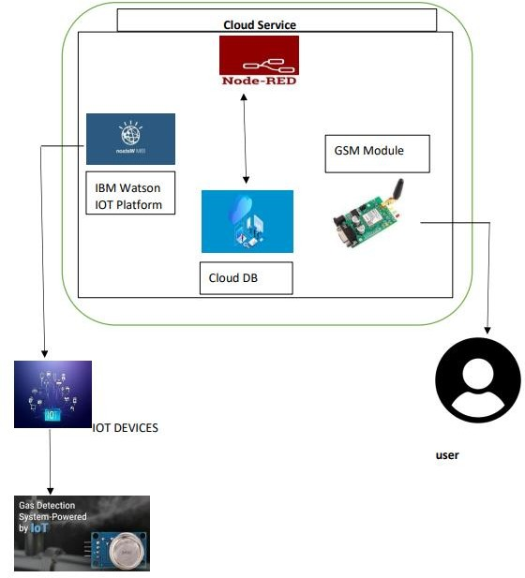
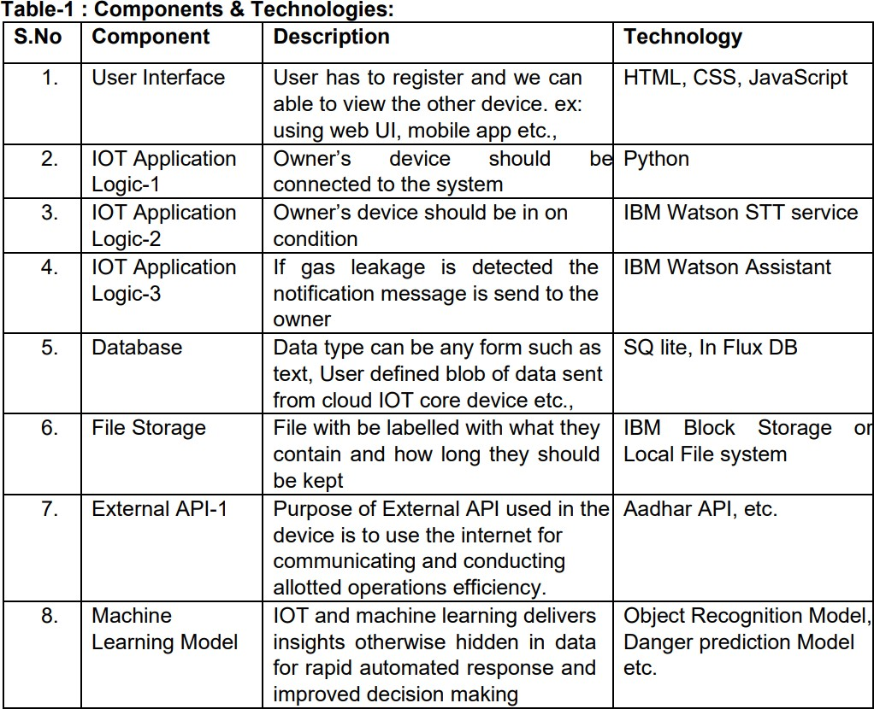
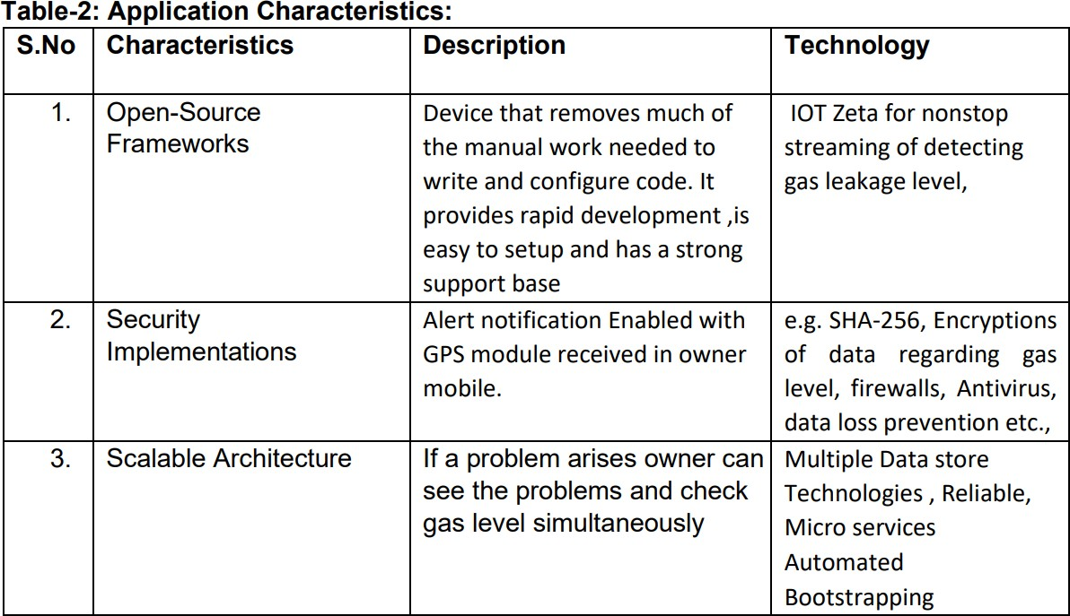
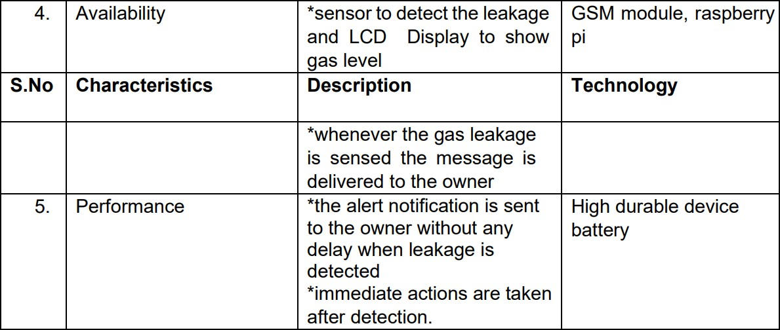
Project Design Phase-II Technology Stack (Architecture & Stack)

Date | 16 OCTOBER 2022
Team ID | PNT2022TMID12971
Project Name | GAS LEAKAGE MONITORING AND ALERTING SYSTEM FOR INDUSTRIES
Maximum Marks | 4 MARKS

Technical architecture:
Figure: Gas Leakage Monitoring and Alerting System

